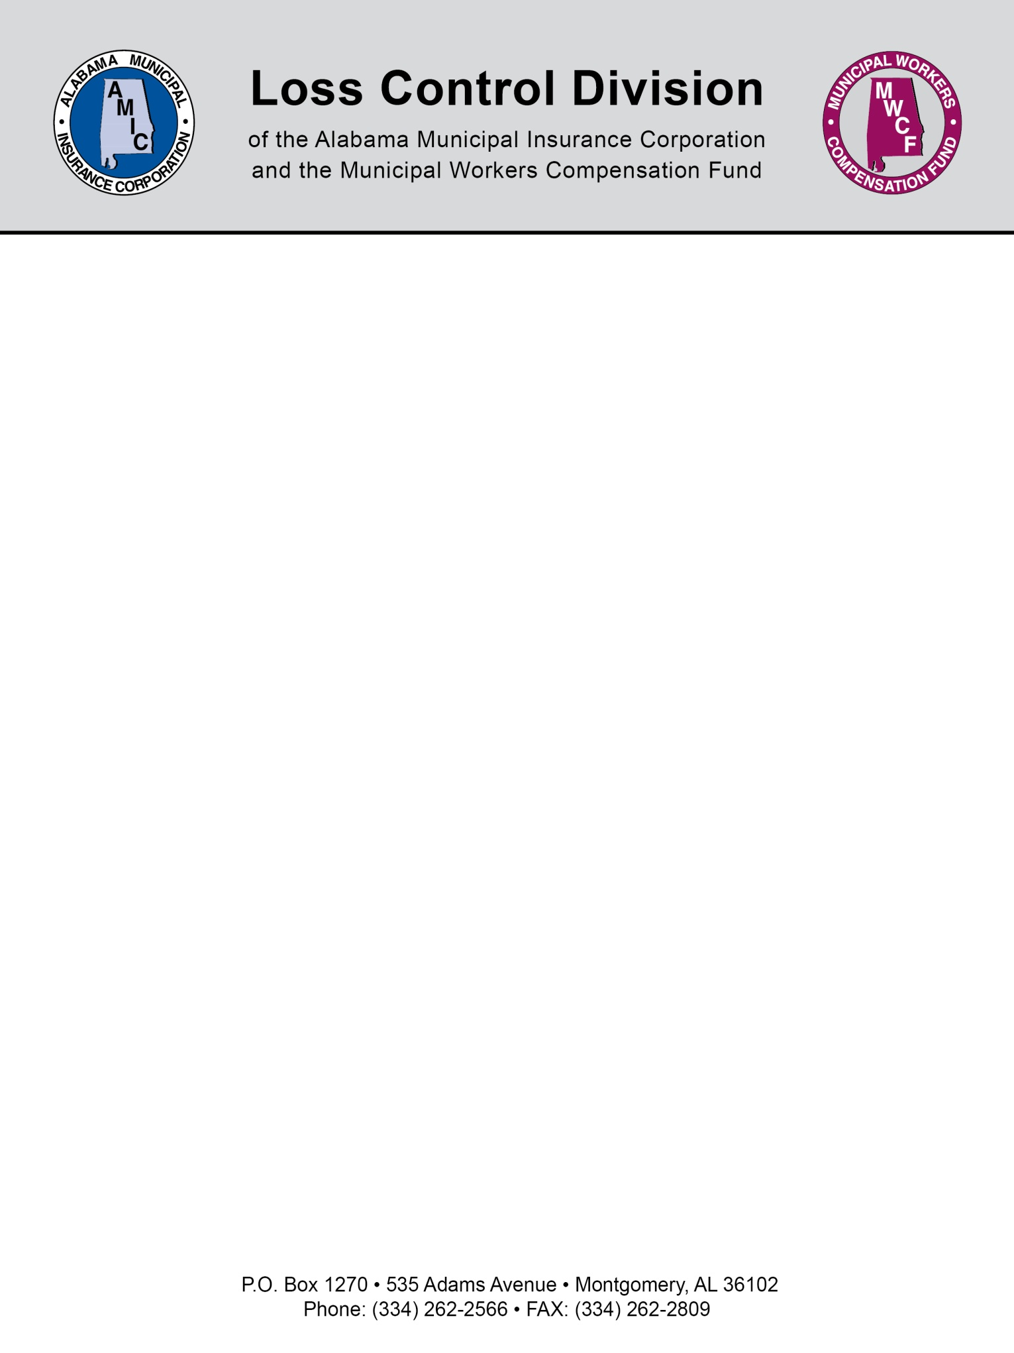

“SAMPLE”
City of ___________________
Motor Vehicle Operations Policy

Purpose: The City of ______________ is committed to insuring that its fleet operations are conducted in a safe and efficient manner. This policy addresses specific responsibilities of those employed whose job duties require that they operate city vehicles or equipment and applies to the City of ______________ employees of all categories. It is the responsibility of these employees to familiarize themselves with this policy and its requirements.

Definition of City Vehicle: A city vehicle is any vehicle or equipment that is owned, leased, rented or loaned to the City of ____________.

Driver’s License Requirements:

A. Prospective and current employees whose job duties include the operation of a city vehicle must be in possession of a valid and current driver’s license to include the appropriate class of commercial license for the vehicle being operated. Under no circumstance shall a city employee whose license has been cancelled, revoked, suspended, or expired operate a city vehicle.

B. Any employee whose job duties include the operation of a city vehicle, shall, within, 24 (twenty-four) hours, notify his/her department head of any change in the status of their driver’s license. Failure to immediately report a change in the status of a license shall result in disciplinary action.

Motor Vehicle Record (MVR) Requirements:

A. Applicants for positions with the City of ________________ that require driving a City vehicle will have his/her current MVR reviewed prior to employment. If the MVR has greater than 8 (eight) points in the preceding 24 (twenty-four) month period listed for traffic violations or a conviction or pending charge for driving under the influence during that period, that applicant will be disqualified for consideration. The applicant is responsible for obtaining and supplying their own MVR at their own expense.

B. All employees whose job requires a driver’s license shall perform a MVR check every 3 (three) years during their birth month. The employee is responsible for obtaining and supplying their own MVR at their own expense. Supervisors shall be responsible for verifying that all other employees have a valid driver’s license prior to operating a City of __________________ vehicle.

C. Anytime a MVR for a current employee whose job duties include the operation of a city vehicle is found to have received more than 8 (eight) points in the preceding 24 (twenty- four) months (according to the points scale for the State of Alabama UTC defense codes), said employee shall be required to attend a City approved defense driving course at said persons expense. The employee will have 2 (two) weeks to present a certificate of completion to their department head or their driving privileges will be suspended until such certification is presented.

Seat Belt Use:
Seat belt use in City vehicles is mandatory for all drivers and passengers in City vehicles. Failure to utilize seat belts shall result in disciplinary action. These offenses shall be treated as “Minor Offenses” in accordance with the City of _____________ disciplinary action.

NOTE: This document is not intended to be legal advice. It does not identify all the issues surrounding the particular topic. Public agencies are encouraged to review their procedures with an expert or an attorney who is knowledgeable about the topic. Reliance on this information is at the sole risk of the user.

Revised 11/2013

